Mean Stack Application – Task Manager

Application Structure:

* Client side – Angular
* Server side – Express
* Database – MongoDB

Required Software’s:

* Node JS
* MongoDB
* Visual Studio Code (Any IDE)
* Robo Mongo (Any IDE)
* Docker
* Jenkins

Client Side – Angular

Angular CLI for building the UI and connects with REST endpoints exposed from server side (express)

**Add Task:**

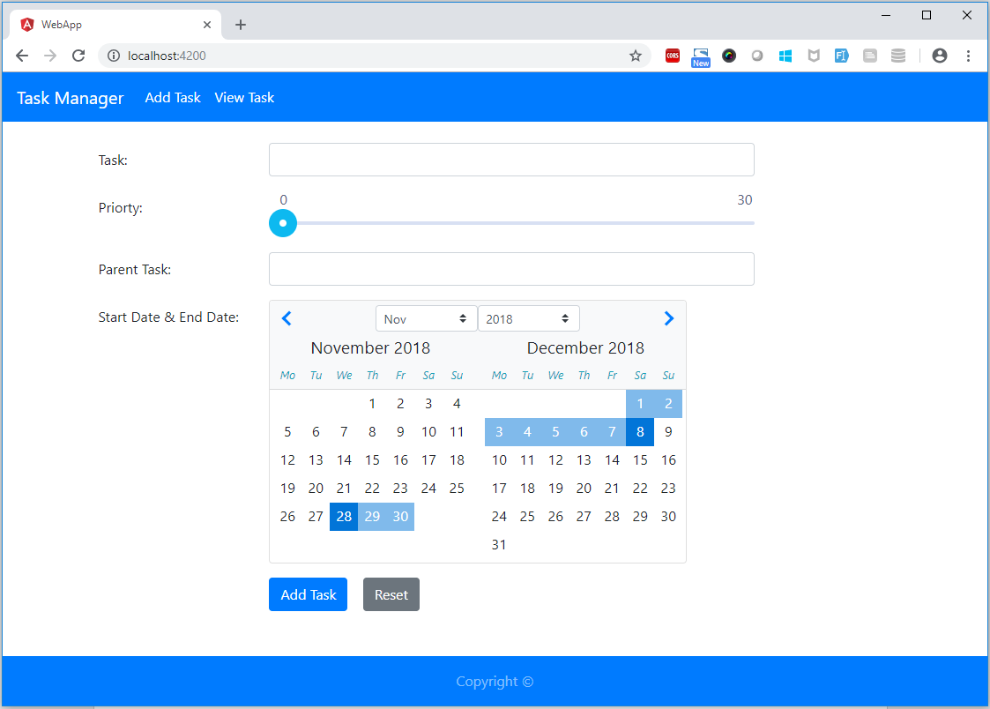

**Edit Task:**

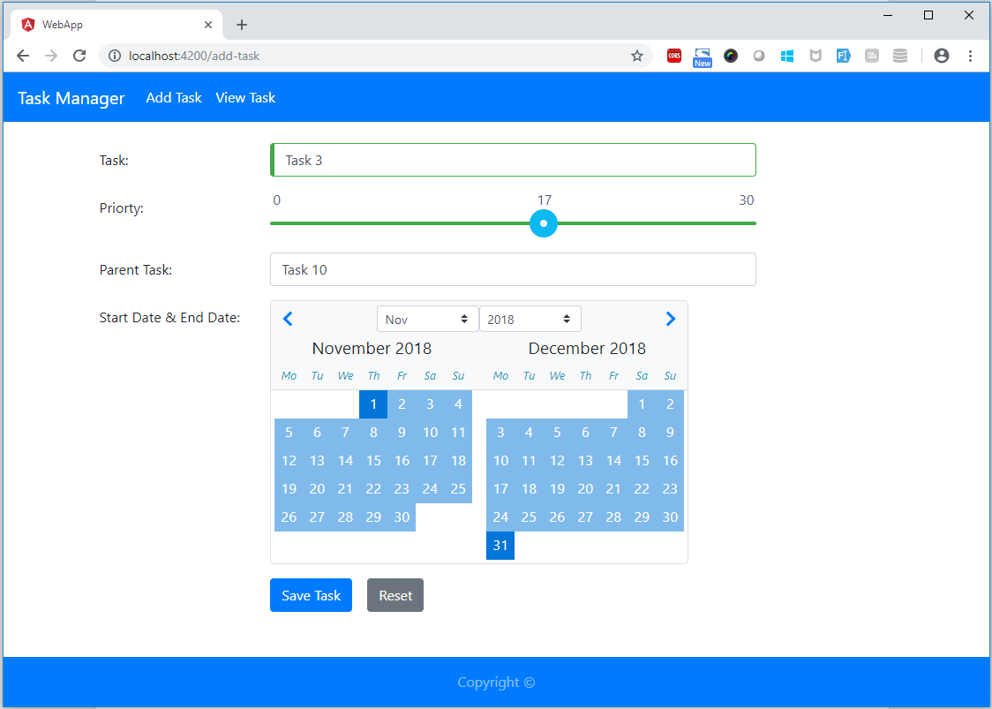

**View Task:**

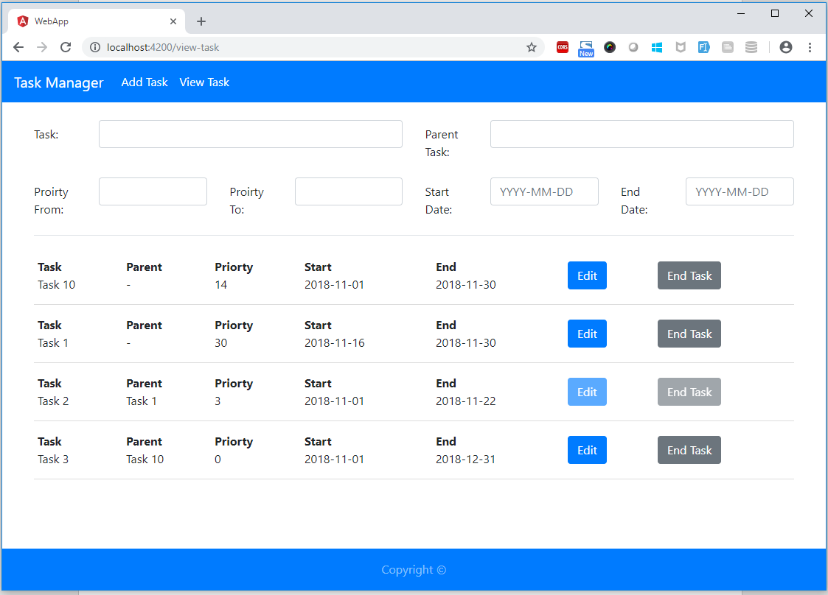

Server Side – Express

Express JS for exposing REST endpoints with MongoDB.

**Add Task – POSTMAN:**

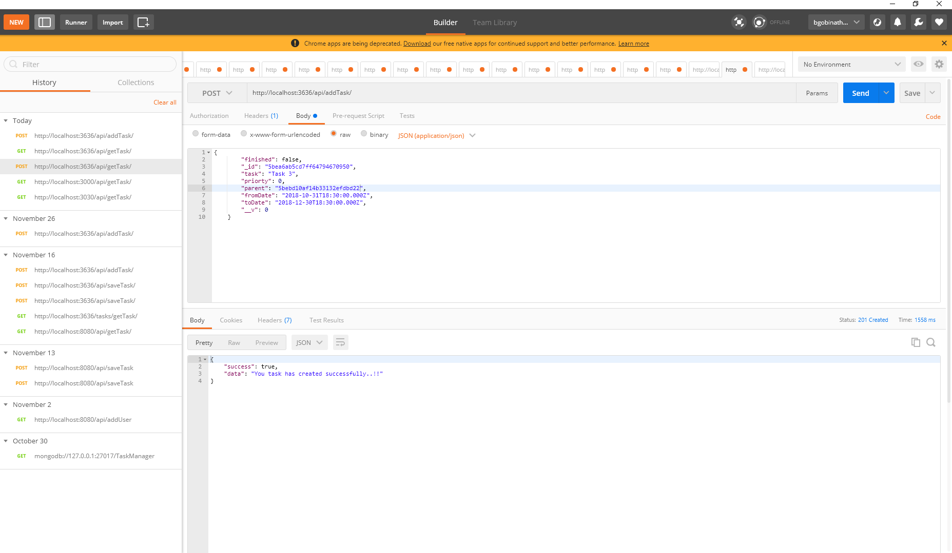

**Add Task – MongoDB:**

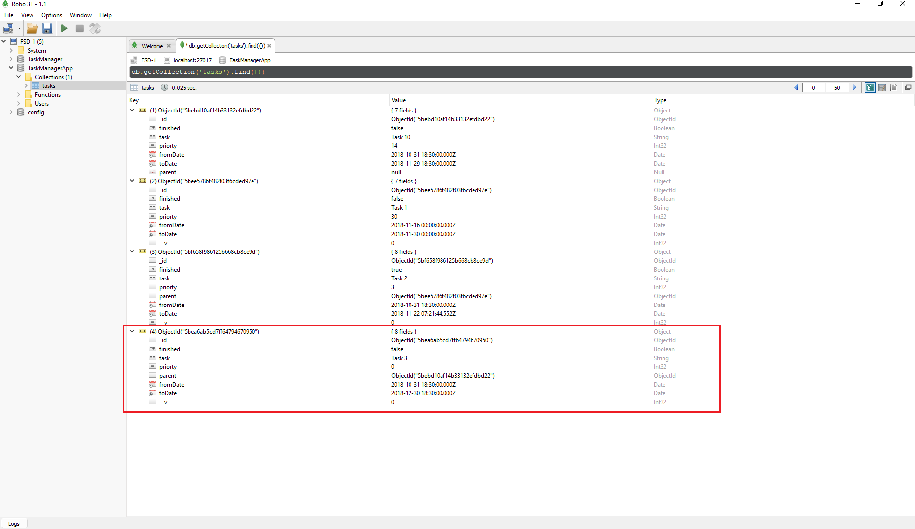

**View Task – POSTMAN:**

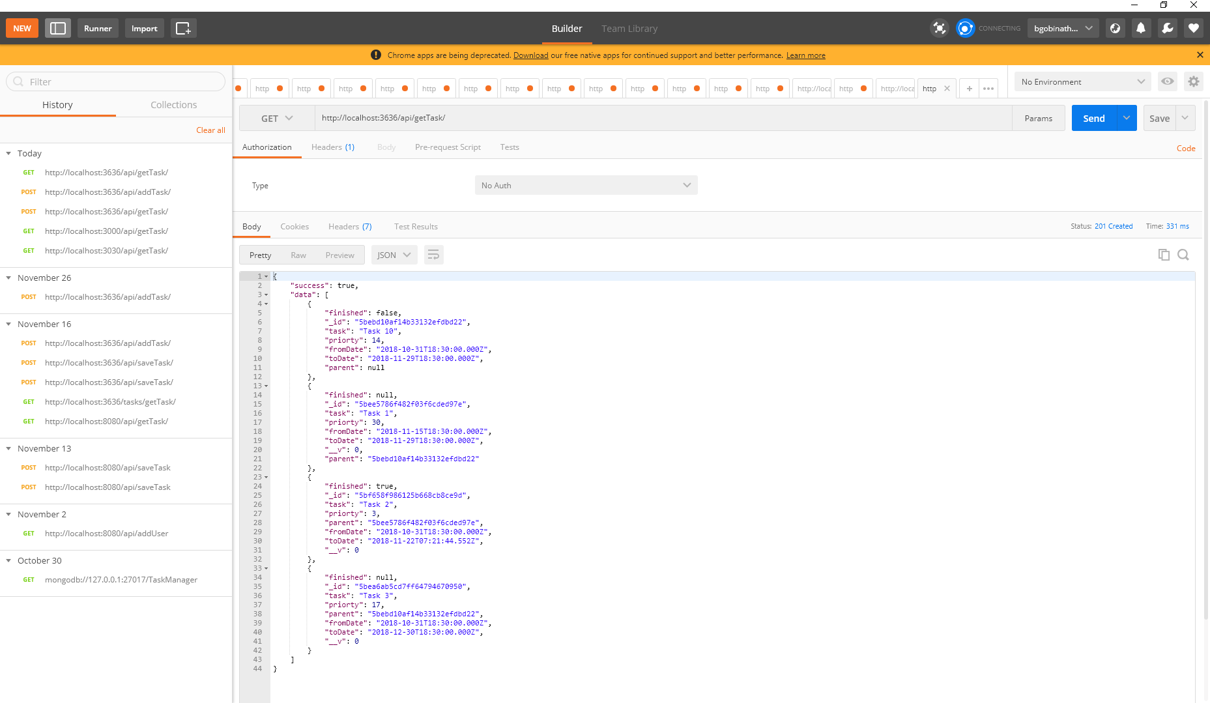

**View Task – MongoDB:**

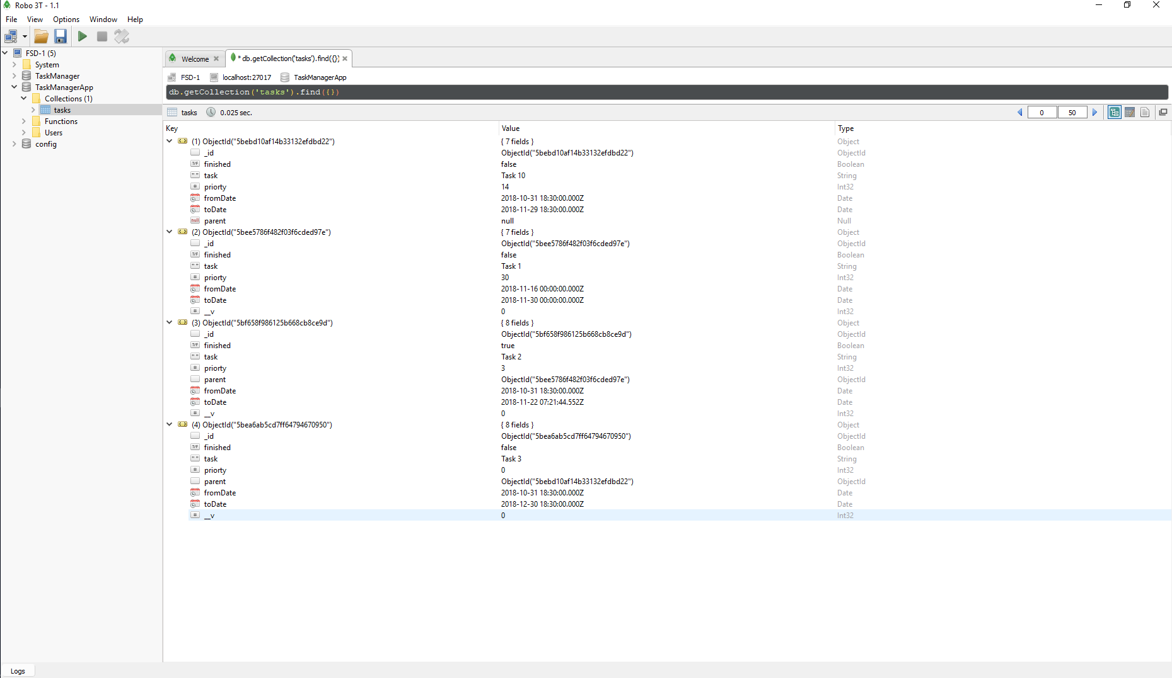

Start Application:

**Client Side – Angular:**

npm install

npm start

Hit <http://localhost:4200/> this url in browser

**Database – MongoDB:**

***Set DB path to run MongoDB:*** mongodb-4.0\bin>mongod –dbpath “...\mean-stack\db”

**Server Side – Express:**

npm install

node app.js

Hit <http://localhost:3636/api/getTask/> this url in POSTMAN to view the list tasks in GET method

Docker:

We have the below listed images and containers are available in Docker before we start implement.

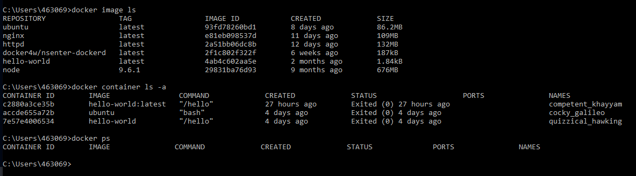

**Run:**

docker-compose up

This will install all the required packages for Angular, Express and MongoDB.

The below highlighted images are created and server is running to corresponding ports.

Client – Angular: <http://localhost:4200/>

Server – Express: <http://localhost:3636/api/getTask/>

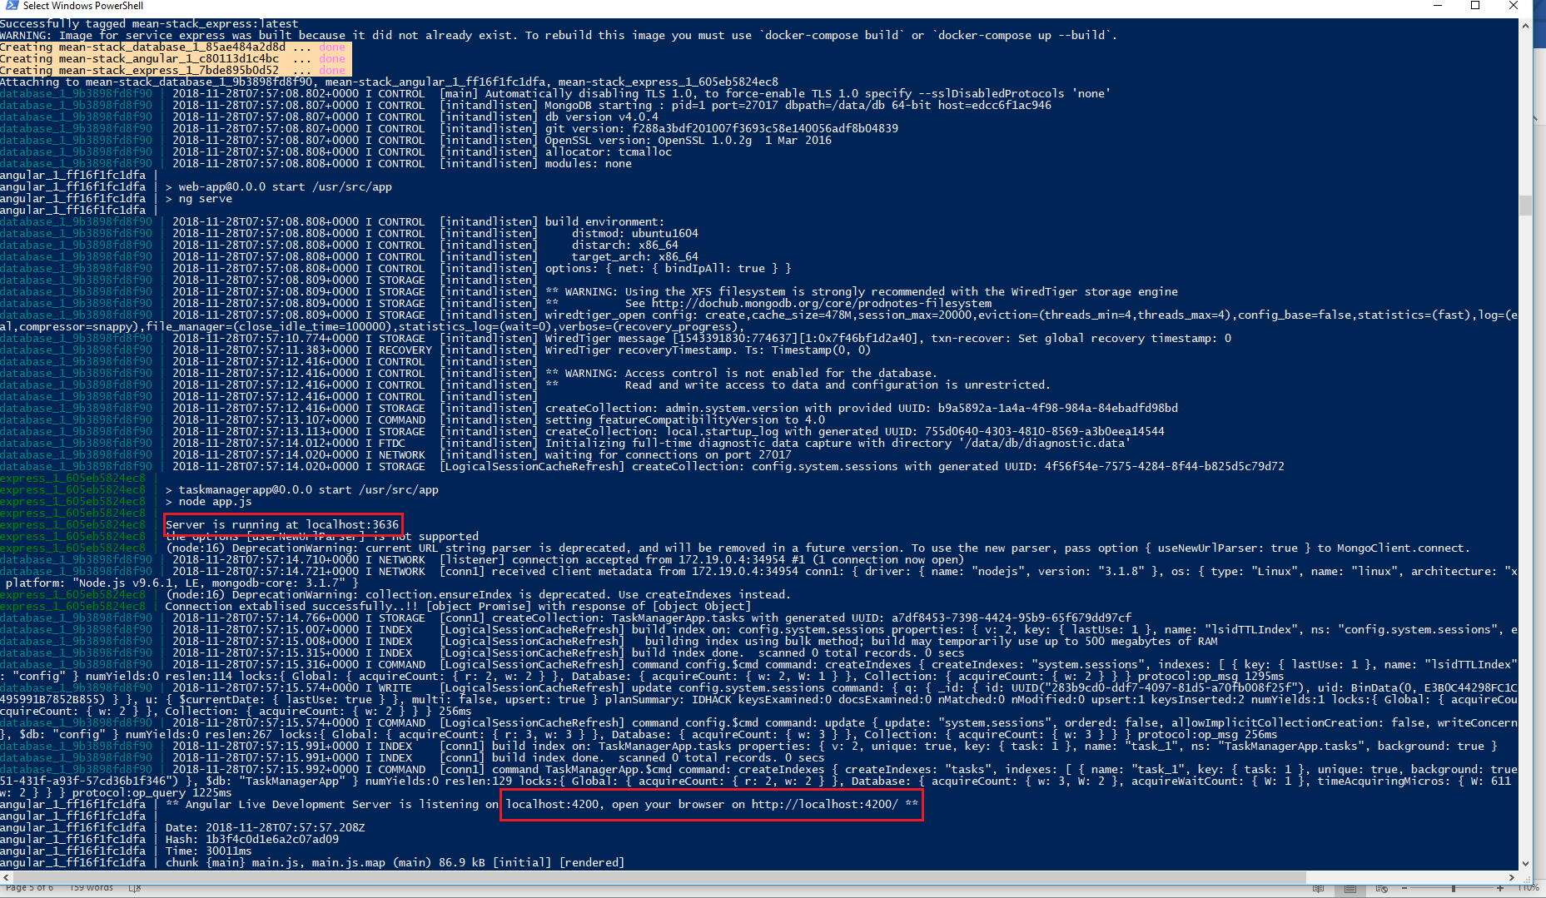

The below highlighted containers are up and running now.



**To hit the URL’s:**

docker exec –it <container_id> sh (Angular container_id e7d7b669dfac)

curl <http://localhost:4200/>

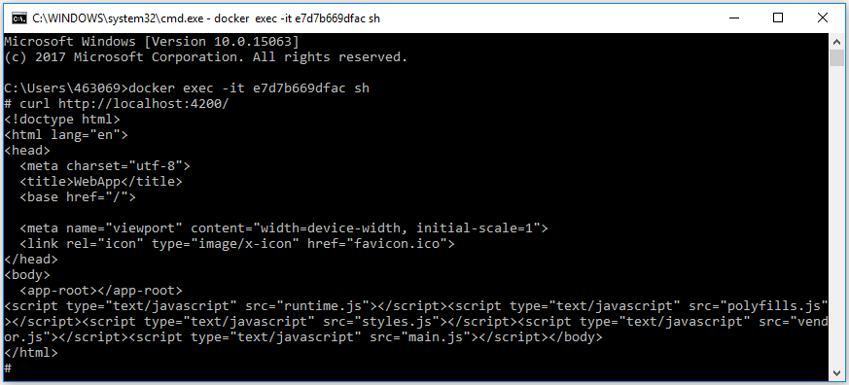

docker exec –it <container_id> sh (Express container_id 3f36864c99e2)

curl <http://localhost:3636/api/getTask>

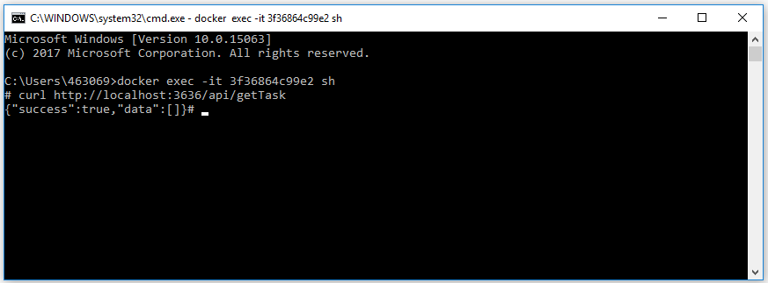

**Note:** I used windows 10 docker, windows port forwarding is not happening to check the URL in browser (application). So, I checked in curl and we are getting the proper response.

Git Repository: <https://github.com/gobinathgithub/mean-stack.git>

Jenkins:

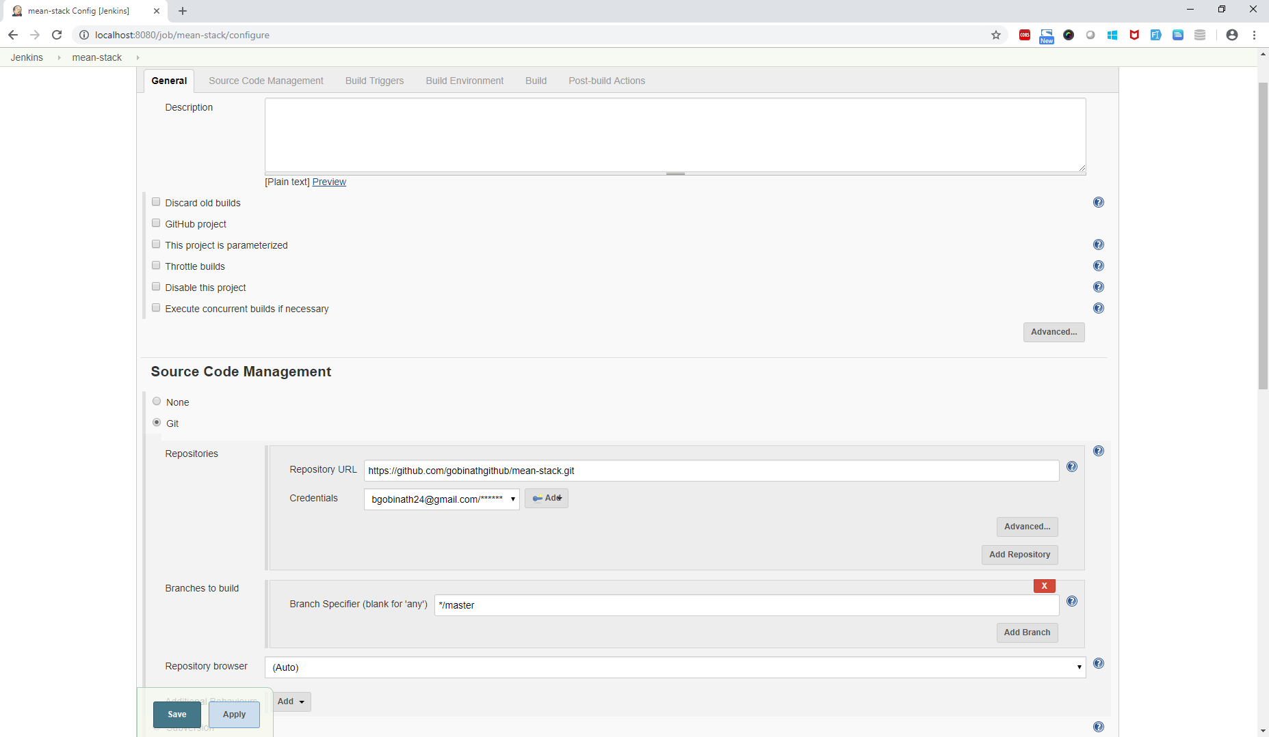

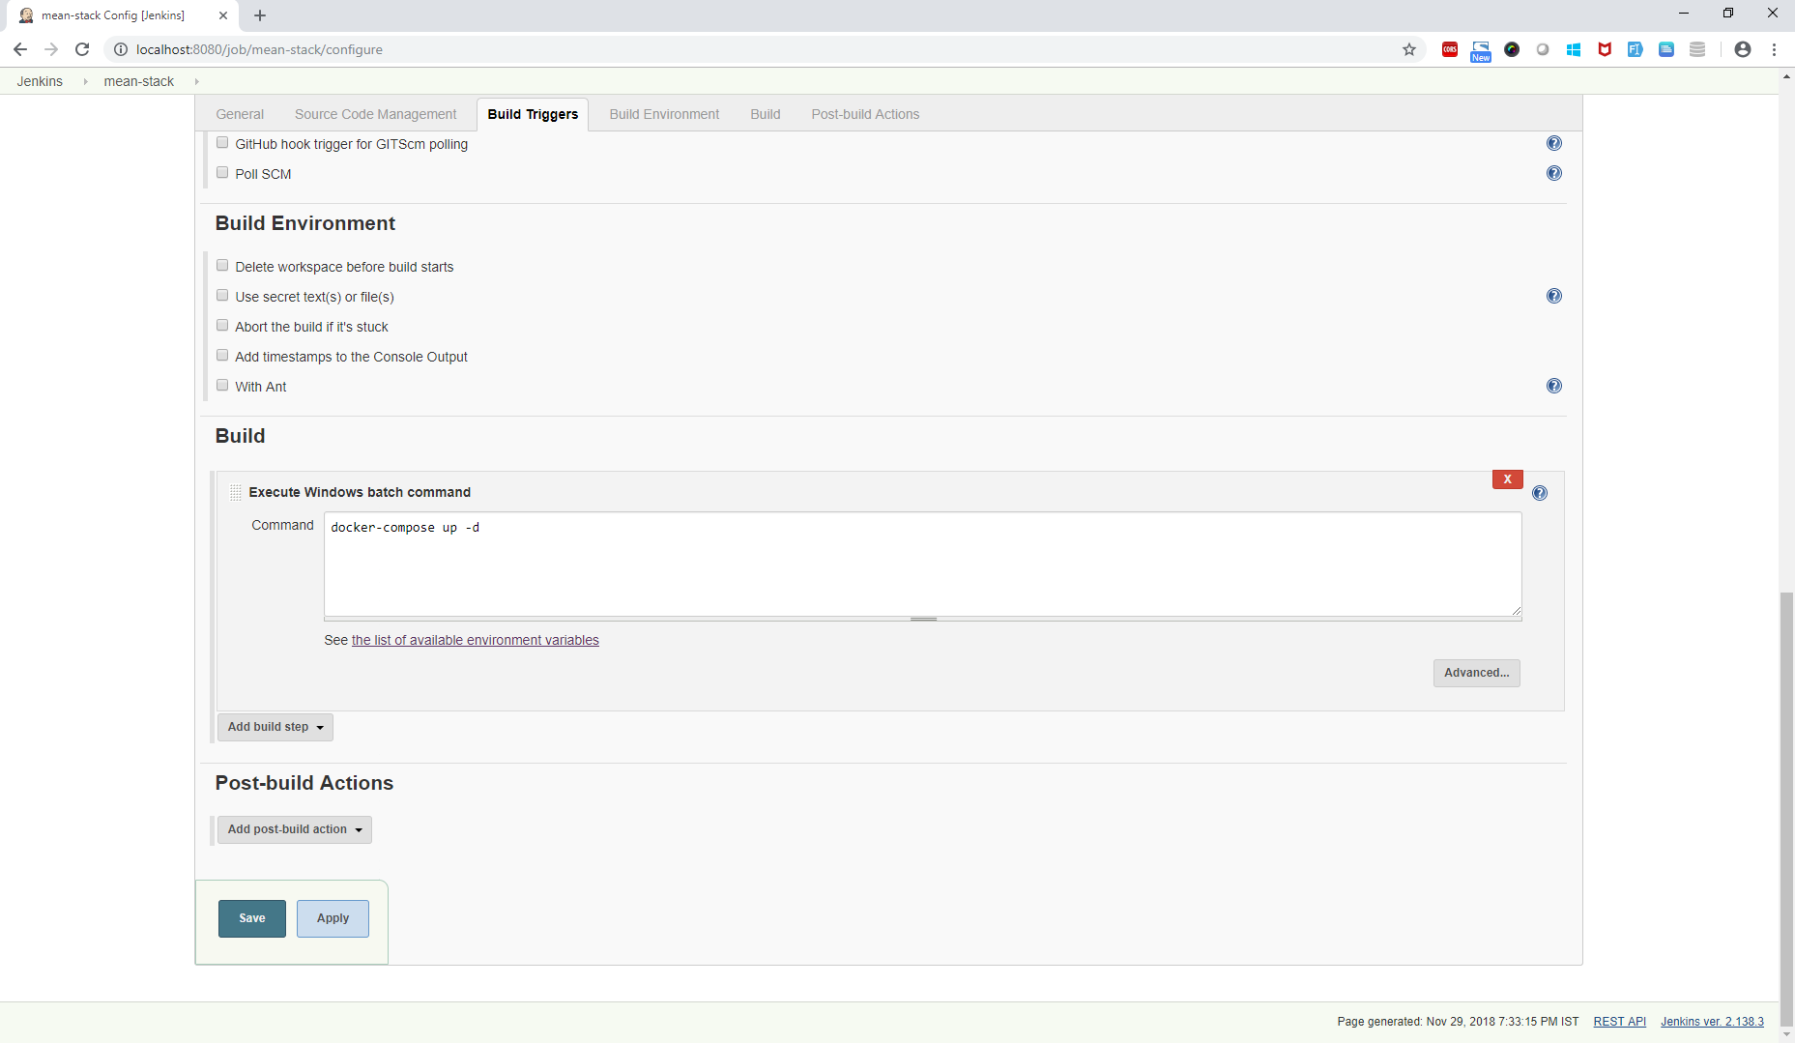

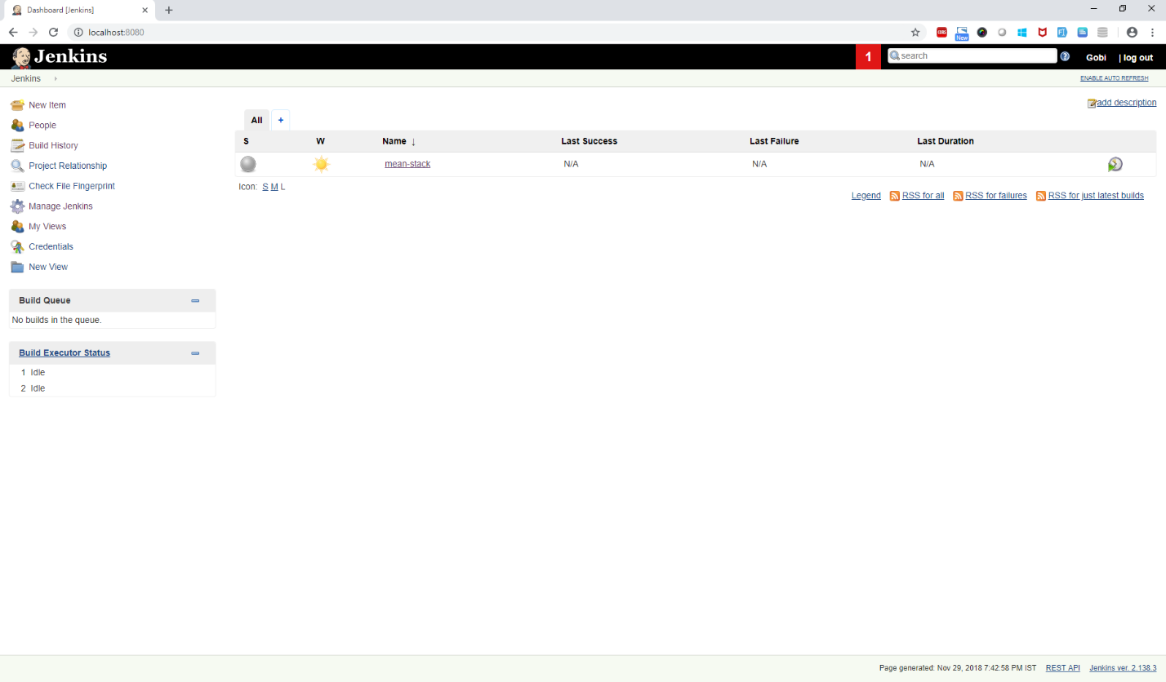

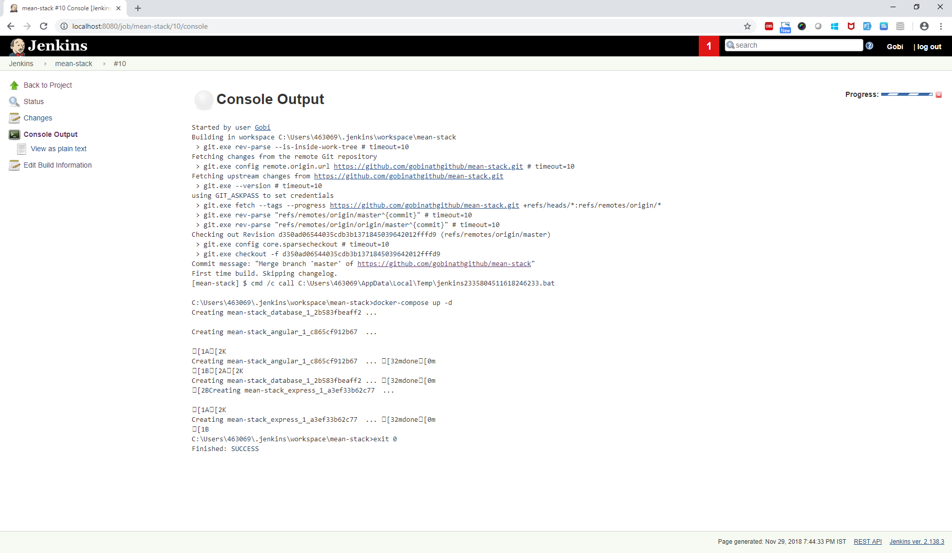

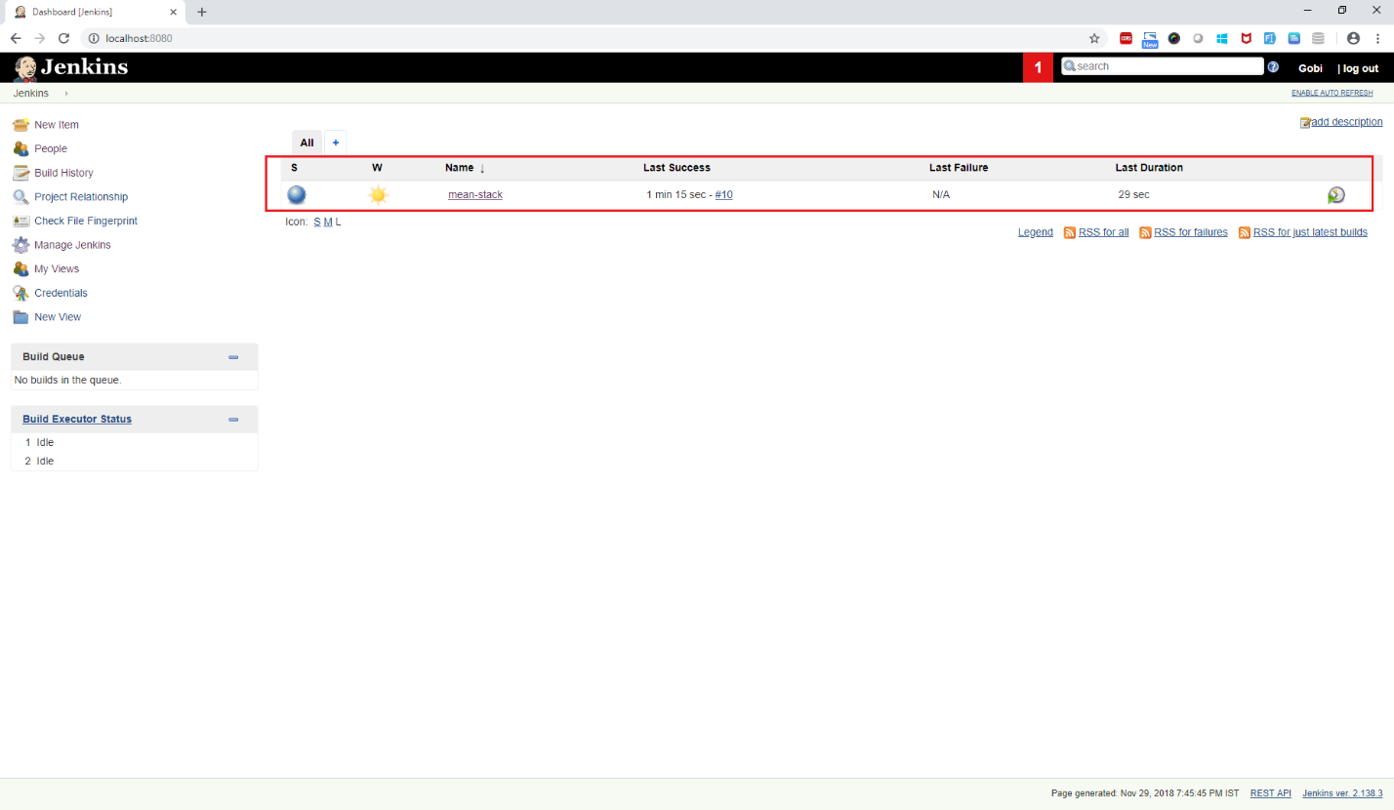

**Log file:**



**Container status**

